M Company Business Proposal
----Group 2

【Abstract】The market plan expounds our market plan including our mission, current situation analysis, SWOT analysis and our market strategies and objectives, revealing our core concepts, views and strategies to win in the severe competition.

Part 1 Executive Summary and Mission Statement
1.1 Executive Summary
Nowadays, mobile phones have become an indivisible part of daily life. Growing needs for GPS, WIFI and multi-media applied in mobile phones make smart phone a new-born product of the mature market of mobile phones, which is also a new-discovered profit growth point. Our new company—M company captures the changing trend aiming to offer fanciers of smart phones more access to amazing experience and realize a win-win situation between the company and customers. Although big brands in the market has already share a large portion of market, increasing need for middle and low end smart phones creates beneficial environment for our products which is a combination of high quality and low price. Besides, our products also satisfy the mainstream needs for larger screen, better-operated system and more personalized application software. Nearly zero-cost online promotion and cooperation with delivery companies and parts suppliers enable us to make profit. So it is reasonable to say we are advantageous enough to capture opportunities in the changing market. However, faced with severe competition, threats exist for we still have weakness such as unsatisfied after-sale service, limited market share etc. Consequently, we plan to take several strategies in comprehensive aspects of promotion, product, price, place, product, people and production. What’s more, we also use tactics to retain and increase loyalty for long-turn development.
1.2 Mission Statement, Target Market and Market segment
Our mission is “to provide brilliant but affordable multi-functional mobile experience for smart-phone-fanciers”. We aim to satisfy needs of smart-phone-fanciers with limited affordability by offering innovative smart phones which are combination of high quality and low costs and relative services.
Our target market are teenagers and middle aged people between 15-40 who are able to adapt to and accept new things quickly and have an excellent understanding of internet business model. They are ones who desire for content experience of mobile multi-function but have only limited affordability or unwilling to spend as much as those top brands of smart phones cost.
Aware of reality of enlarged size of potential customers characterized as our target market above in China, our company is established to fill this special part of market. It is obvious that our product and service is exactly what our target consumers look for. Our company and our target customers share the same core values of being innovative, adaptive and vigorous.
For market segment, firstly, we divide the market into smart phones fanciers and not smart phones fanciers. For the smart phones fanciers, we further divide sub-market into very high income, high income, middle income, low income, very low income according to standards of income levels adapted to China. Our target market as explained above is the smart phones fanciers with middle or low income. Distinct from other mobile phones company, we have only one type of major product with express target market. We conceive in this stage, especially in the severe competitive market, focusing on one unique type of product is a strength rather than weakness. This stands our company out especially for our target consumers. It is even more prospective to take into the rapid growth of our target markets in China recently. What’s more, it is concentration on mono-type segment makes our nearly zero-cost promotion possible; otherwise, imagine if we have more segments, it is quite likely that on-line promotion will be not wide-covering and efficient enough. However, in the long run, target market, segment as well as strategies will change according to the capital accumulation resources expansion and higher stage of development.

Part 2 the Current Situation Analysis – The Internal Landscape
2.1 Product and Service
2.1.1 Major Product
Our major product is a type of dual-core smart phone named M-phone. Not only it looks simple, concise and well-designed, but also the phone is well equipped with long-lasting battery (15 hours for continuous calling, 45 hours for playing music songs, 12 hours for watching videos and 6 hours for large games), signals supporting 7 channels including GSM and WCDMA, two sets of positioning system—GPS and GLONASS, Wi-Fi and Bluetooth, android M system operating system research and developed independently. What’s more, in the bottom of the phone is a user-defined multifunctional button named “MI Button” providing high degree of freedom for users. Besides the smart phones, we also offer exclusive mobile phone devices and parts for function, decoration and M-phone protection.
2.1.2 M System
M system is an operating system which was exploited by M company, based on Android system. M system has more than 100 improvements of Android.
M system has many special features:
1. Greatest Mobile phone theme library which can provide maximum flexibility to users.
2. Unique user experience design better fits Chinese people’s using habits.
3. Free clouds service which can backup important data.
4. Double version coexistence, meet different users’ requirements.
2.1.3 “M Chat Software” (a Social Chatting Software)
M chat software is a free social chat tools which can be used by i-phone Android and Symbian mobile platforms and all the telecom operators in China. It provides free text, voice messages, sending photos etc.
M chat software has many special features:
1. It achieved chatting by voice messages.
2. It supports voice blog which could make your friends know your thoughts and moods.
3. Users could look up people nearby to know more people and make friends.
2.2 Pricing
For the smart phone, we provide a low price at 2000RMB, almost half of average price of other dual-core mobile phones. The first 1000 customers of every time’s product launch can get 15% discount.
In the contrast, for the exclusive mobile phone devices and parts for function, decoration and mobile-phone protection are offered at relatively high prices for its uniqueness, which is also an important part of our profit.
The M system and “M chat software” software are free for every registered member of our official website for we conceive the wide spread of the software is an extremely efficient promotion of our company.
2.3 Place
In order to control the cost to realize our mission, the only sales channel is through the Internet—on the homepage of the company. There are two ways for payment: payment online or cash on delivery. We cooperate with professional logistics company to save the cost and guarantee the process of production distribution and delivery.
2.4 Promotion
Similar to the place, we promote our products mainly online, while supplemented with other methods such as product launch. Following are the four ways described in detail:
2.4.1. Information Delivery
From the very beginning, news from the inside of M company is let out little by little; this causes a lot of guesswork, and quickly become a hot topic on internet. Not until a high-profile news conference of the new product, does it uncover the veil. Undeniable, this high-profile propaganda makes all the media pay attention to the phone, everywhere on the network and filled with M phone. This is a powerful propaganda method.
2.4.2 Virus Marketing
Maybe you do not focus on the IT products, but you still know them mobile phone, because all your friends are talking about it anytime. Out of curiosity, you also begin to understand the M phone and so you also involuntarily become the virus disseminator. Through various ways of communication between people, M mobile phone achieves brand input and promotion.
2.4.3 Event Marketing
After the M phone’s news conference, the mysteries of M phone is all discovered, very low price, super configuration, high cost-performance etc. M phone grasps the attention from thousands of people and the online attention number soar to rise rapidly to 20 thousands.
2.4.4. Blog Marketing
Before the M phone launch, the team gives full play to the social media---microblog’s influence. For instance, they use their blog to share pictures and characteristics of M phone with their fans, dig out M’s selling point through some small applications and topics interact with blog users. The team members are all celebrities in IT industry, each of them has a number of fans, and therefore, their blogs’ marketing functions are made great use of.
As a consequence of our promotion strategy, M phone doesn’t use any advertisement with costs, but depending on the internet, M team realizes the promotion of M brand successfully by virus marketing.
2.5 People
As a company with short history and relatively small scale, members of our team members are controlled within 300 including a core team of 7 people. Through strict entry-selection and relative trainings for employers, employers are all people who committed to the core value of the company and thus the quality of service can be ensured.
2.6 Production
M phone needs the transformation of Internet technology in the mobile phone industry to gain success. First, the DELL model of supply chain management to realize the zero-stock, on-demand customization. Second, it is kind of Amazon model of channels to reduce the cost of delivery. Third, it is based on the social media to achieve zero cost marketing.
M company gets the demand from those phone users making their order on the website, and then purchases different parts from different suppliers through the supply chain. This reduces the cost extremely.
Through the website, M company can exactly predict the capacity of the market according to such links: settling the limitation of purchasing and making an order before purchase which could avoid the risk of inventory and return of goods.

Part 3- the Current Situation Analysis – the External Landscape
3.1 The Macro External Environment Analysis – PEST Analysis
Macro external environment to modern company is water to fish. This part we explore the macro external environment using PEST analysis. With regard to our target market being domestic market, we focus mostly on the environment in China.
3.1.1. Political Factors
Firstly, declining tariff due to China’s joining WTO in 2001 contribute to companies reducing costs for raw material, parts and accessories, which means more capital available for R&D. Secondly, the wide existence of illegal copycat smart phone swallows a considerable portion of middle-range and low-end market recently. However, the government is making effort on relative anti-policies to justice market competition. Thirdly, improving regulations and laws about mobile internet and short messages and better patent protection benefit the whole mobile phone market.
3.1.2 Economic Factors
It is lucky for M-phone to not need to take limited powerful entity-channel into account for all of the selling is on-line. What worth attention is the trend of globalization, which enables domestic smart phone to take the most advantage of foreign technology, product parts etc. But on the other hand, higher degree of market opening brings with forceful foreign rivals crowding into domestic market. Besides, smart phones are more affordable now with more residents remaining income thanks to economic boom.
3.1.3 Social Factors
When applying Maslow’s hierarchy of needs theory onto psychological changes of mobile phone users, it is reasonable to find out customers today are looking for phones fashionable as well as multi-functional. Requirements for long duration, user-friendly interface and system, supportive attributes for 2D and 3D games, camera with higher pixel and powerful data transmission have become an unavoidable mainstream. In addition, people are more likely to accept fresh things in a shorter time as the level of education promotes.
3.1.4 Technological Factors
Single-chip which integrated all of necessary functions in one piece of chip saves numerous space and cost for mobile phone production, thus low-end phones with better experience are turned into reality. In China, smart phones equipped with CDMA(Code Division Multiple Access) based on single-chip resolution show profitable performance in the market. Additionally, breakthroughs in semiconductor technology push forward the technology innovation in the whole industry. Finally, more and more companies nowadays are relying on on-line promotion owing to the prosperity of on-line medium.
3.2 Market Overview
3.2.1 Growth of Market
The global mobile phone market achieved strong growth in 2011 showed in data that mobile phone sales and relative revenue increased more than 12 percent compared to the previous year. Overall, the total mobile phone sales in 2011 reached 278 million and sales revenue was $ 172.2 billion.
With the rapid growth of smart phone sales, data predicted that the market revenue will grow by eight times in the next three years. Last year, the total income of the smart phone applications was $ 1.94 billion and in 2013 it is expected to grow by 807 percent, to $ 15.65 billion. With the main driving force of the smart phone in the world, analysts expect that use of smart phones will grow to 970 million in 3 years.
What’s more, China's smart phone market acceptance is ahead of most emerging markets, except for Brazil and Russia (Graph 1).

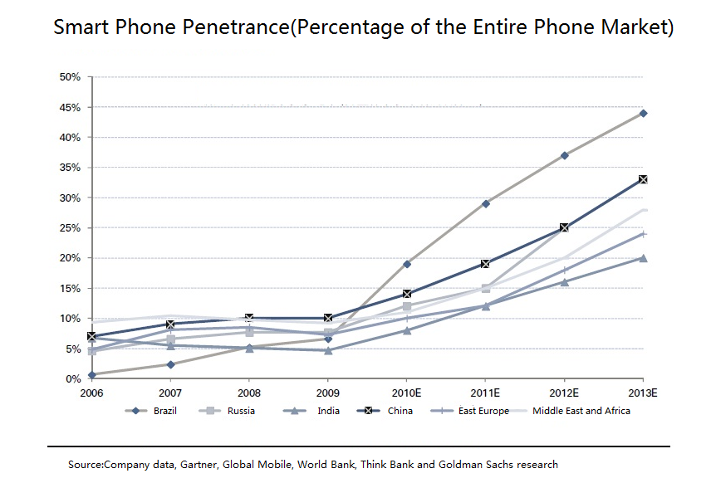
Graph 1

3.2.2 Structure of Market
For the smart phone system, Smart phones have five major operating systems, as follows: Nokia's Symbian platform, Microsoft's Windows Mobile platform, Linux platform, Google's Android platform, the Apple iPhone Mac platform as well. After Nokia acquired Symbian on June 2008, handset manufacturers, chip vendors, operators all targeted on the open source operating system, which make competition intensified between mobile phone platforms.
For the users of smart phones, there are two characteristic: About 90 percent of 3G users are younger than 30 years of age(Graph 2); more than 50 percent of 3G users have less than 2500 RMB($ 370) income(Graph 3).

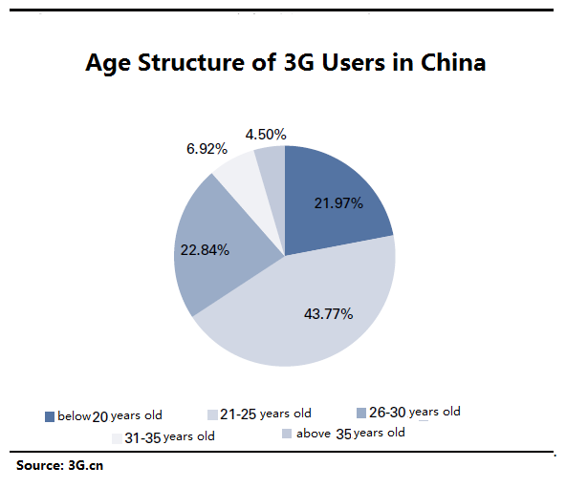
Graph 2

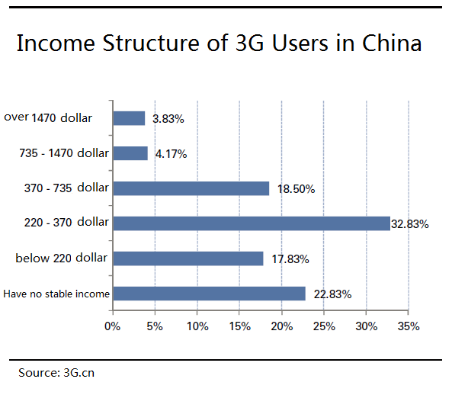
Graph 3

3.2.3 Trends of Market
With the rapid development of smart phones, one of the top five smartphone operating system, Google Android system is becoming a most popular commodity in many terminal manufacturers, that’s why the M phone developed on the basis of the Android system, its M system operating system supplies some gaps on the Android system, making it more convenient and efficient to operate. Only M phone and its super-functional design can be compared with the Apple phone in the domestic mobile phone market. But the price is lower compared with Apple. All in all, visible market environment is very impressive.
3.3 Competitor Analysis
3.3.1 Brand and Product Awareness Analysis
Our brand is under great pressure faced with competition against existent smart phone brands such as Apple, Samsung, HTC, Nokia etc. Graph 1 shows brand awareness proportion of smart phones occupied by different brands in 2012. According to the data (Graph 4), Samsung, HTC and Motorola make the top three. 6 major brands make up 76.9% of the market share.
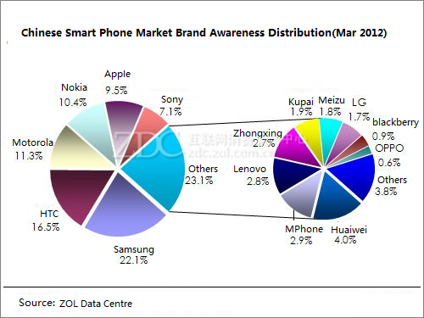
Graph 4

As for the product awareness, the data from graph 5 tells that Apple 4S attracts most attention in China, with an awareness proportion of 4.1%, followed by HTC G11 and Samsung GALAXY. When it comes to the product quantity on the top chart, HTC ranks first with 5 products on the chart, Samsung second with 3 products on the top list.

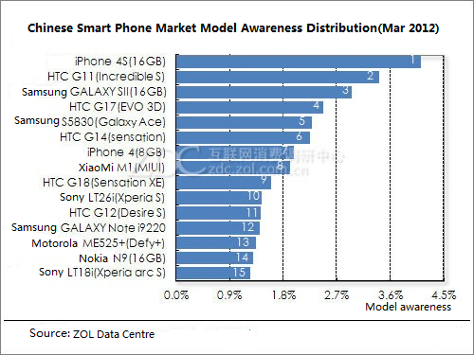
Graph 5

3.3.2 Awareness Analysis of Products Sorted by Price Level, System and Screen Size
1. Products of Different Price Levels
According to the graph 6, smart phones at price between 1000-2000 RMB attract most attention (34.5%), followed by middle and high end products priced between 2000 RMB and 3000 RMB. Generally, smart phones under 3000 RMB constitutes mainly part of domestic market of smart phones.

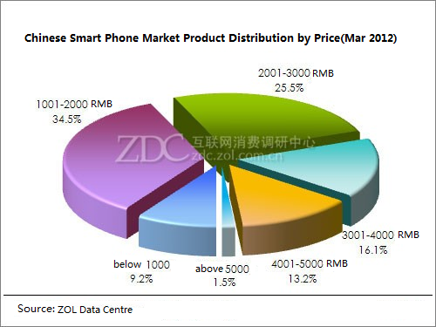
Graph 6

2. Products of Different Systems
Data in graph 7 below tells the system attract most attention is Android, with a proportion of 74.5% in customers’ attention, while none of the awareness proportion of other system exceeds 10%.

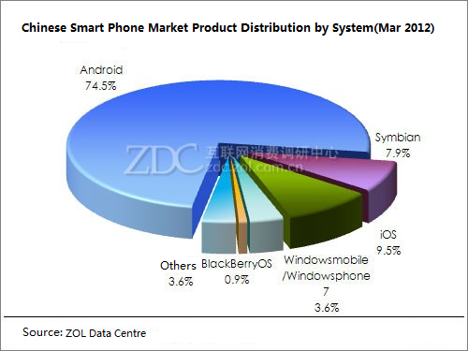
Graph 7

3. Products with Different Screen Sizes
Rapid development of touch-screen phone directly leads to larger and larger size of phone screen. Conclusion can be drawn from graph 8 that mobile phones with larger screen are favored by more and more smart- phone users as the data below tells that smart phones sized between 3.3-4.0 inches win the awareness proportion of 55.6%. What ranks second is smart phones with super-large screen larger than 4 inches, attracting attention of more than 30%.

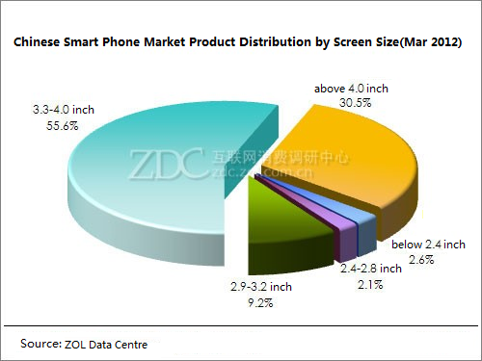
Graph 8

3.3.3 Summary
The results of awareness analysis above illustrate two facts. On the one hand, strength of competitors’ especially major companies in the area can never be underestimated though they are not as superior as before. It is fundamental to be highly conscious of fresh movements of competitors. On the other hand, M phone with a price under 3000 RMB, a system developed based on Android system and a size of 4.0 inches perfectly fits into the mainstream of needs, with an inestimable prosperity. Again, challenges always come with opportunities in the market.

Part 4 – SWOT analysis
4.1 Strengths
Firstly, for the phone itself, it is the first dual-core smart phone in China equipped with the most powerful and fastest phone chip currently in the world—MSM8260 and the fluency and HD function make the phone a top brand in the area of smart phones. The internal phone system which is updated weekly to revise in previous bugs and add new practical functions guarantee the improving and the freshest experience of fanciers of smart phones. What is even more precious is that our phone focus on the basic function of a mobile phone such as the duration of batteries and the phone signal for phone calls which is easily neglected compared to the major trends of enriching various applications and functions. Besides, as a phone designed particularly for Chinese, the phone is with a screen sized 4 inches fitting in Chinese’s hands well and the M system developed independently matching perfectly with the using habits of Chinese.
Secondly, the most attractive point of the phone is to the best configuration with the lowest price at a mainstream cost of 2000RMB. Extremely low cost on promotion, cooperation with delivery and production partners and the strategy to only keep 15% gross profit enables us to have an absolute advantage in price compared to similar products.
Thirdly, when place is considered, the successful mode of selling entirely online saves a considerable large amount of costs. The win-win relationship with delivery partners like EMS etc. supports the essential link of product delivery.
Lastly, the outstandingly professional R&D team of the company mostly working for top companies in the area before, who are the source of creation new product and new phone system, enable the company to grow sustainably in a world where innovation counts more than ever before.
4.2 Weaknesses
Though prospective with superior strengths, there is still room for the company to improve in contrast to competitors.
Firstly, lack of front-facing camera and some quality problems with the hardware disappointed some supporters of our phone. Secondly, lacking in good reputation and stable brand image, the new-start company only occupy a small portion of market share. Thirdly and the most urgently, current after-sale service through online and service stores cannot well satisfy the needs of customers. More service stores and relative staffs are still required to shorten the waiting time.
4.3 Opportunities
Yet, the global trend of mobile phone computerized and prospective development of the mobile terminal create an unprecedented opportunities for smart phones. The potential market for smart phones expands rapidly, especially in the part of those who are not rich enough to buy top brands of smart phones like iPhone but still desire to own one. Thus it can be confidently said that our smart phone combined with high configuration and low cost correspond just rightly to the changing needs. Besides, the bottleneck of innovation for top brands in the world weakens the power of rivals and leave even larger market space for new companies.
4.4 Threats
Opportunities always coexist with threats. Competition can never be relaxing in a promising industry. With a different target market from top brand such as Apple and Samsung, it is still challenging to capture the low-end and mid-range market when other companies whether domestic or foreign are eyeing the same target market as well. What’s more, using hardware of giant suppliers aiming to cut down costs comes with a drawback of low independent property.
4.5 Summary
Affordable price along with remarkable quality, weekly-updated system developed independently which is adapted to Chinese and the online marketing essential for maximizing the efficiency of promotion with the lowest costs outstands M-phone in the competitive market. The increasing needs create an excellent market environment for M-company to grow rapidly as long as the supplying, selling and delivery can be ensured.
However, in the long-run, the company still has a lot to overcome for better market share. Hardware of higher quality and better after-sale service are in demand. Building distinctive and impressive brand images to win loyalty among target customers is also a must for sustainable development and expansion in scale. Also, faced with threats like severe competition and variety of rivals, more independence on property rights is asked for. To keep irreplaceable advantage in the market is the most cardinal stress to win in the competition.

Part 5 Objectives – the internal landscape
5.1 Promotion
In order to improve brand awareness, M company needs to find our more marketing tools. Ask more people to understand M Phone brand and its property. At the same time, make it more complete over existing market tools.
5.2 Product
One of the important advantages, the M system, is basically adapted to Chinese people. So we want to do a specific of scale consumer survey at regular intervals like Focus Group, interview and so on, in order to understand the trend of consumers.
5.3 Price
In terms of price strategy, M company will continue the low-cost strategy, because Chinese consumers are very flexible on the price. Low cost on promotion and cooperation with delivery will be continued as well because that’s a good way to reduce cost.
5.4 Place
China's three major telecom operators - China Mobile, China Unicom and China Telecom – have 564million, 160million and 80million mobile users, respectively. Differ from the United States and some European countries(80 percent of mobile phone operators pay subsidized sales), 80% of the 2G mobile phones are sold through open channels in China, while only 20 percent of mobile phone operators to sell. Cooperate with the three major operators, by way of the sales contract, M company provide specific lock on mobile phone for specific operators.
5.5 Product
Develop more applications like “M chat software” in order to attract more customers.
Enhancing brand power will inevitably involve high-technology products. M company will consider to launch our own high-technology and high-priced mobile phone model, but its main model will be still in the usual low-price strategy in the near future.
5.6 Production
Long picking time is one of the dissatisfactions over our customers, because M company produces products after getting orders. In this regard, marketing department will be set up, and estimate the potential customer regularly, in order to produce in advance.
5.7 People
As the company grew, M company not only needs to expand employees, but also change the structure of the company's employees at the appropriate time. The company staff structure is linear now, but in the near future, M company will rebuilt the network type or even a shareholder system, and the ultimate aim is for successful listing.
5.8 Strategies for Attracting and Retaining Customers
We use two strategies to attract and retain customers.
Firstly, reduce the rate of defection. It is essential for keeping customers and increasing business. Mode of on-line sale assists us to measure retention rate by order database. Besides, relative reviews in on-line sale and after-sale system stimulate us to find out the causes of dissatisfaction and improve those that can be managed better. For example, as a respond to the increasing complains about our after-sale service, we plan to increase human resources and capitals put into this part and set up more maintaining stores in more cities all over the country.
Secondly, increase the longevity of the customer relationship. We establishes a sub-website named “M-society” in our home page to create a virtue community for our potential, current and previous customers to communicate hot topics about our product as well as variety issues about smart phones, ranging from application software to skills for maximizing usages of smart phones. In the e-society, people are involved into newest information of our company and product, in a voluntary way. Smart phones, unlike other mobile phones, really takes skills and knowledge to manipulate well. Enormous resource and sharing of experience build a powerful platform between smart phone fanciers. As the provider of the platform, we definitely will build stronger bond with customers and attract new customers.
Besides two strategies above, we provide discounts of 5% for previous buyers and extra bonus such as gifts of dolls of our mascot to increase loyalty.
5.9 Customer Psychology Analysis
Customer psychology is forever a decisive factor for whether strategies will achieve objectives. Here we analyze the characteristic of our target market psychology and predict their possible respond to our actions.
Our target customers as illustrated in part 2 are sensitive to price, well conscious of new changes in market, adaptive to new information and active in the internet. Thus, we predict our new strategies will have a notable impact rapidly especially when our future strategies in place, product, production and people will visibly improve their experience. As our price strategy is to mainly remain low price, so as long as our target customers are sensitive to price, our product will still attract to them in a high degree.

Group Members: Sun Wenliang(1500022724)
Zhang Xinkun(1500022720)
Huang Hanyu(1501210915)
Wang Kangjin(1501210996)
Liang Ming(1500022770)

The approximate exchange rate for RMB and GBP is 10:1.
All of data in this part comes from ZDC, which stands for Zhongguancun On-line Data Center. Zhongguancun is a big trading venue for all kinds of electronic products.

